# CS 255 System Design Document Template

This template lays out all the different sections that you need to complete for Project Two. Each section has guidance to prompt your thinking. You will need to continually reference the interview transcript as you work to make sure that you are addressing your client’s needs. There is no required length for the final document. Instead the goal is to complete each section based on what your client’s needs are. Remove this note when you are finished, and replace all bracketed text with the relevant information.

## UML Diagrams

### UML Use Case Diagram

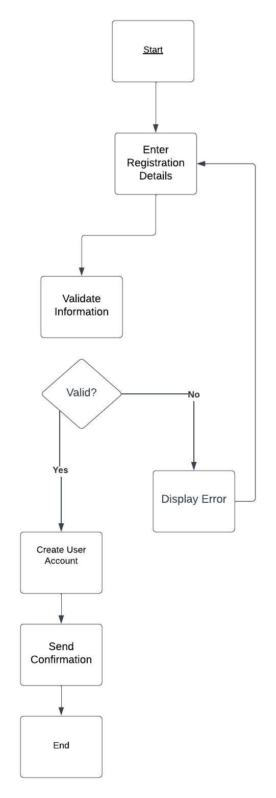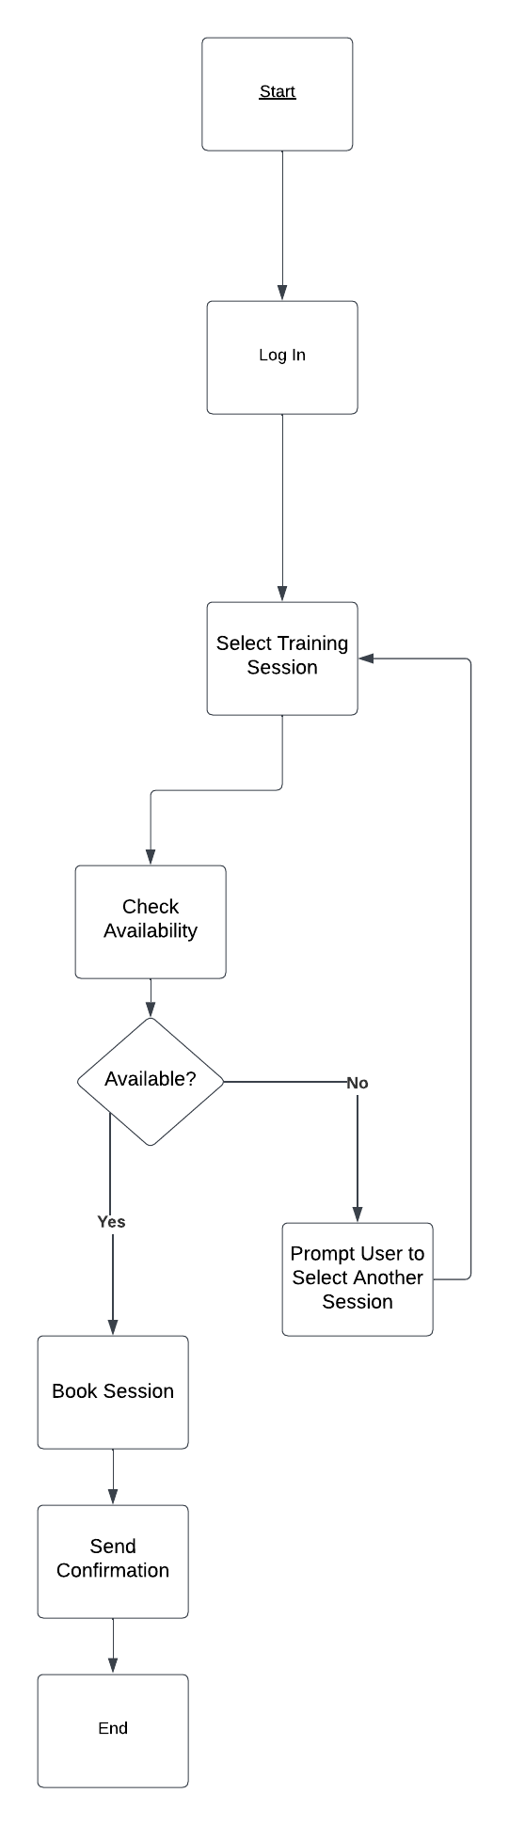

### UML Sequence Diagram

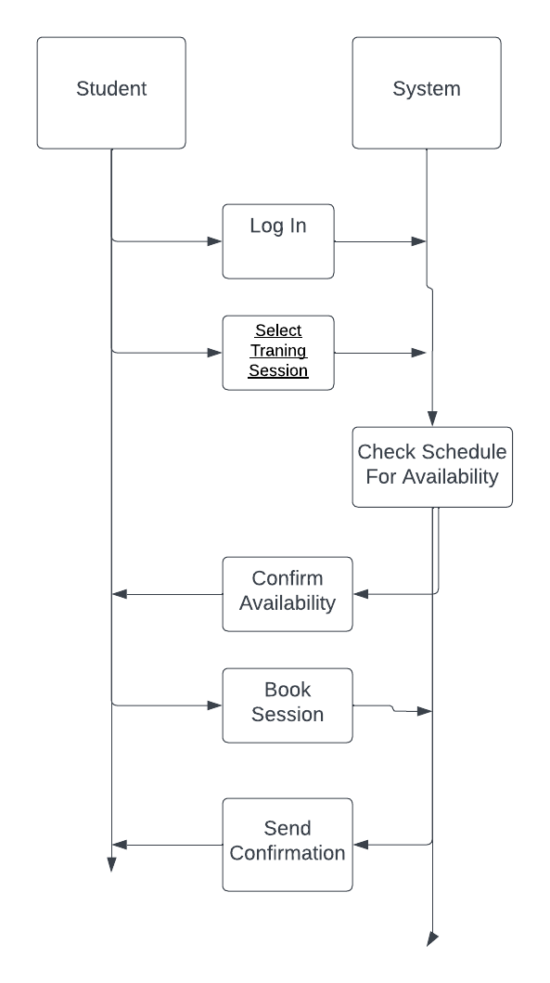

### UML Class Diagram

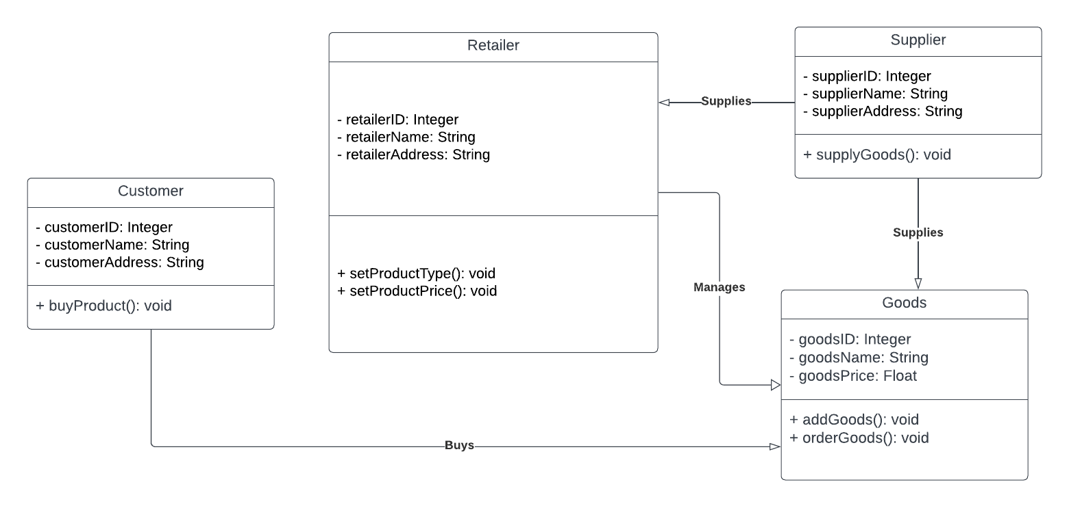

## Technical Requirements

*The driverpass system will require a technical infrastructure that can meet all functional and nonfunctional requirements specified in the business requirements document. High-performance servers are essential for hosting the web application, database, and other backend services. With this in mind, using a cloud-based service like Amazon Aws, Microsoft Azure or IBMs cloud services are able to provide these needs to the customer. Doing so can save the client money by avoiding the need to build in-house servers. This is also great for when driverpass needs to scale upwards, as it can provide better performance and security.*